A

Project Report On
“
ONLINE SHOPPING PORTAL
”

VIVEKANAND COLLEGE, KOLHAPUR.

“BACHELOR OF COMPUTER APPLICATION”

FOR THE AWARD OF BY
Satyjeet Sanjay Patil (1759)
Abhishek Tanaji Patil (1732)

UNDER THE GUIDANCE OF Mrs. S. B. Rajhans

THROUGH
VIVEKANAND COLLEGE KOLHAPUR.
(2024-25)


CERTIFICATE

This is to certify that,
Mr. Satyjeet Sanjay Patil
Mr. Abhishek Tanaji Patil
B.C.A-III (SEM-VI) has submitted this project entitled “ONLINE SHOPPING PORTAL” For the present semester, this project is carried out under my guidance and supervision and best of my knowledge, this is their original work and has not been present
earlier.
Place: Kolhapur Date:

Miss. Swapnali B. Rajhans MR. V.B. Pujari
(Guide) (Co-ordinator)

Examiner:
1)
2)

It is our great pleasure that we submitted the project
entitled " ONLINE SHOPPING PORTAL " We thankfully acknowledged the endless help and support that we have obtained from “Mr.V.B.Pujari” (Cordinator Dept. of BCA) from the stage the project was conceived. The journey of this project was possible due to our project guide "Miss. Swapnali B. Rajhans" For giving us valuable guidance for the
completion of the project. Last but not least, we would like to express our sincere gratitude to those who have helped directly or indirectly in our project.

Place: Kolhapur Date:

We undersigned hereby declare that this report entitled “ONLINE SHOPPING PORTAL” is an original work prepared by us under the guidance of Prof
“Miss. Swapnali B. Rajhans” The empirical findings in this report are based on data
collected by us. The matters reported in this report are not copied from any source.

We understand that any such copy is liable for punishment in any way the university authorities deem to fit. This work has not been submitted to the award of a degree to VCK (Autonomous), Kolhapur.
This work is humbly submitted to VCK (Autonomous), Kolhapur for the award of the degree of Bachelor of Computer Application (B.C.A).

Place: Kolhapur Date:

NAME ROLL NO.
Satyjeet Sanjay Patil (1759)
Abhishek Tanaji Patil (1732)

INDEX

Sr. No | Contents
1 | Introduction To Project  - Introduction  - Existing System  - Need and Scope
2 | Proposed System  - Objectives  - Requirement Engineering:  - Requirement Gathering
3 | System Analysis  - System Diagram:  - DFD  - ERD
4 | System Design  - Database Design  - Output Design
5 | Implementation  - System Requirement  - Hardware  - Software
6 | Output (Report)
7 | Conclusion and Suggestion:  - Conclusion  - Limitation  - Suggestion
8 | References:  - Website  - Books

Introduction

1. Introduction
The Online Shopping Portal stands as a pioneering initiative, meticulously crafted by a vibrant student team, to redefine the landscape of Online Shopping Portal In an era
marked by rapid technological advancements and shifting consumer preferences, this application emerges as a significant leap forward. It embodies a thoughtful response to the evolving needs of contemporary consumers, presenting a comprehensive solution to transform the grocery retail experience.

With a laser focus on user convenience, the Online Shopping Portal is designed to offer a seamless and efficient platform for procuring essential goods. Technology plays a pivotal role in enhancing the shopping process, ensuring a user-friendly interface that simplifies product selection, cart management, and order processing. Moreover, the app's commitment to community engagement distinguishes it from traditional models. Features such as user comments and reviews create an interactive space, allowing users to share insights, recommendations, and collectively contribute to an enriched shopping journey.

This collaborative effort by the student team is more than just a technological innovation; it is a testament to their dedication to making daily essentials accessible with unprecedented ease. As the Online Shopping Portal endeavors to reshape the
Online Shopping Portal paradigm, it aspires not only to meet but to exceed the expectations of users, fostering a sense of connection and community within the realm of online Shopping Portal

- Existing System

In traditional online shopping portal, customers physically visit stores, leading to time constraints and potential inefficiencies. The Online Shopping Portal addresses these issues by providing a digital platform for convenient shopping, eliminating the need for physical presence.

3 Need and Scope of Computer System

The need for a computerized system is driven by the desire to enhance:
  - Convenience: Allowing users to shop from anywhere, anytime.
  - Efficiency: Streamlining the process of product selection, cart management, and order processing.
  - Learning Experience: Providing students with hands-on experience in application development and project management.

Proposed System

- Objectives
  - User-Friendly Interface: Develop an intuitive interface for a positive user experience.
  - Efficient Order Processing: Streamline cart management and order processing for efficiency.
  - Community Engagement: Foster user interaction through comments and ratings.
  - Inventory Management: Implement a robust system to monitor stock levels.
  - Accessibility: Enable convenient anytime, anywhere Online Shopping Portal

- Requirement Engineering

  - Feasibility Study: Assess technical, operational, and economic viability.
  - System Requirements Specification: Define functional and non-functional requirements.
  - Analysis and Prototyping: Understand user needs, refine designs through prototypes.

- Requirements Gathering
  - User Insights: Gather preferences and expectations through interviews and surveys.
  - Stakeholder Feedback: Engage stakeholders for valuable insights.
  - Competitor Analysis: Identify successful features and market trends.
  - Market Research: Stay informed on evolving user expectations and technology trends

System Analysis

- Site Map:

- Data Flow Diagram

Level 0:

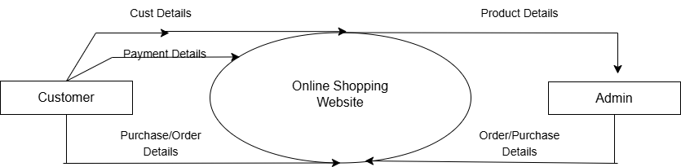

Level 1:

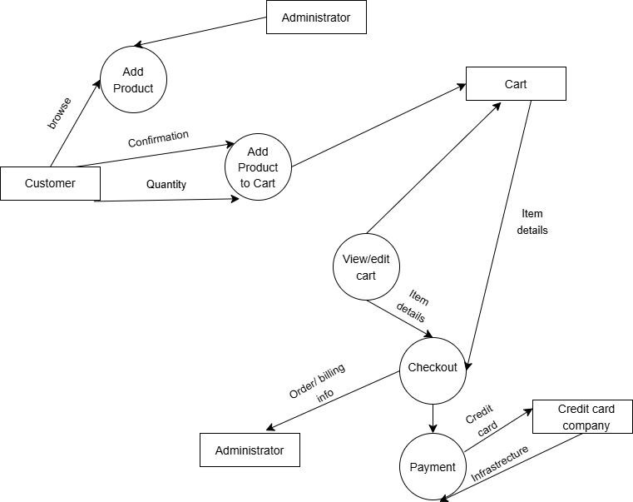

3: Entity-Relationship Diagram of Online Shopping Portal

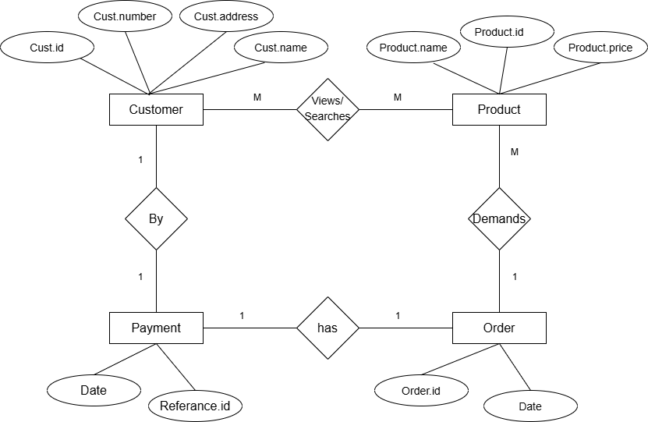

SYSTEM DESIGN

Database Design:
Admin:

Column | Data types | Constrains
Username | Varchar | -
Password | Int | Primary key

Category:

Column | Data types | Constrains
id | Int | Primary key
CategoryName | Varchar | -
CategoryDescription | Varchar | -
CreationDate | Date | -
UpdationDate | Date | -

Order Products:

Column | Data types | Constrains
id | Int | Primary key
userId | Varchar | -
productId | Varchar | Foreign key
quantity | Number | -
orderDate | Date | -
paymentMethod | Varchar | -
orderStatus | Varchar | -

Order Track History:

Column | Data types | Constrains
Id | Int | Primary key
orderId | Int | Foreign key
status | Varchar | -
remark | mediumtext | -
postingDate | timestamp | -

Product reviews:

Column | Data types | Constrains
id | Int | Primary key
productid | Int | -
Quality | Int | -
Price | Int | -
Value | Int | -
Name | Varchar | -
Summary | Varchar | -
Review | Longtext | -
reviewDate | timestamp | -

Products:

Column | Data types | Constrains
Id | Int | Primary key
Category | Int | Foreign key
SubCategory | Int | -
productName | Varchar | -
ProductCompany | Varchar | -
productPrice | Int | -
productDescription | Longtext | -
Productimage1 | Varchar | -
Productimage2 | Varchar | -
Productimage3 | Varchar | -
shippingCharge | Int | -
productAvilability | Varchar | -
postingDate | Timestamp | -
UpdationDate | Varchar | -

subcategory:

Column | Data type | Constraints
Id | Int | Primary key
categoryId | Int | -
subcategory | Varchar | -
creationDate | Timestamp | -
updationDate | Varchar | -

Userlog:

Column | Data type | Constraints
Id | Int | Primary key
userImage | Varchar | -
userIp | Binary | -
loginTime | Timestamp | -
Logout | Varchar | -
Status | Int | -

Users:

Column | Data type | Constraints
Id | Int | Primary key
Name | Varchar | -
Email | Varchar | -
Contact No. | Bigint | -
Password | Varchar | -
ShippingAddresse | longText | -
shippingState | Varchar | -
shippingCity | Varchar | -
shippingPincode | Int | -
BillingAddress | longText | -
billingState | Varchar | -
Billingcity | Varchar | -
Billingpincode | Int | -
Regdate | Timestamp | -
updationDate | Varchar | -

Wishlist:
l
Column | Data type | Constraints
Id | Int | Primary key
UserId | Int | -
productid | Int | -
postingDate | Timestamp | -

Output:

Home Page:

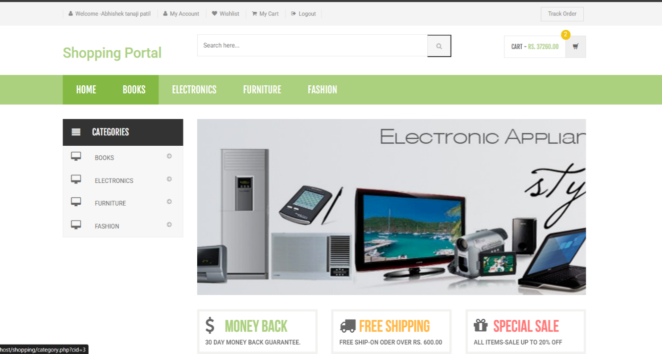

Categories:

Books:
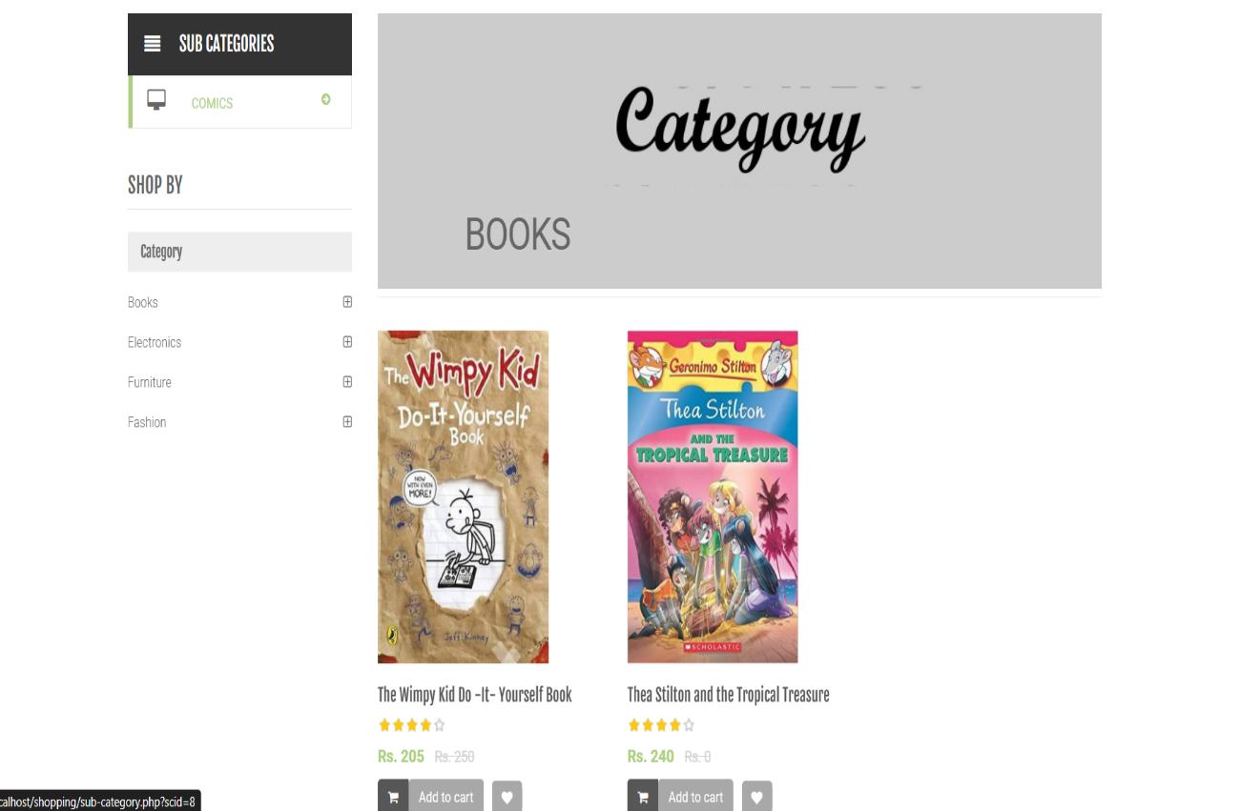

Electronic:
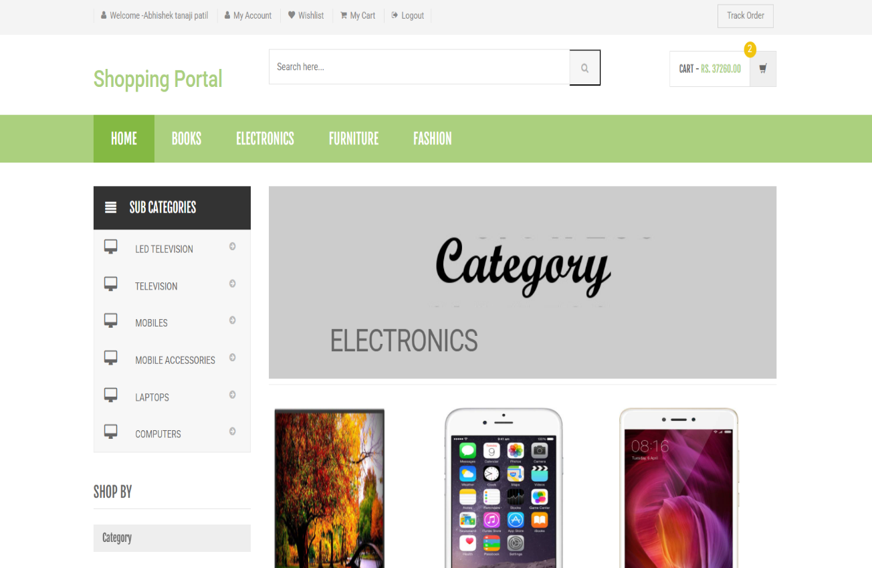

Furniture:
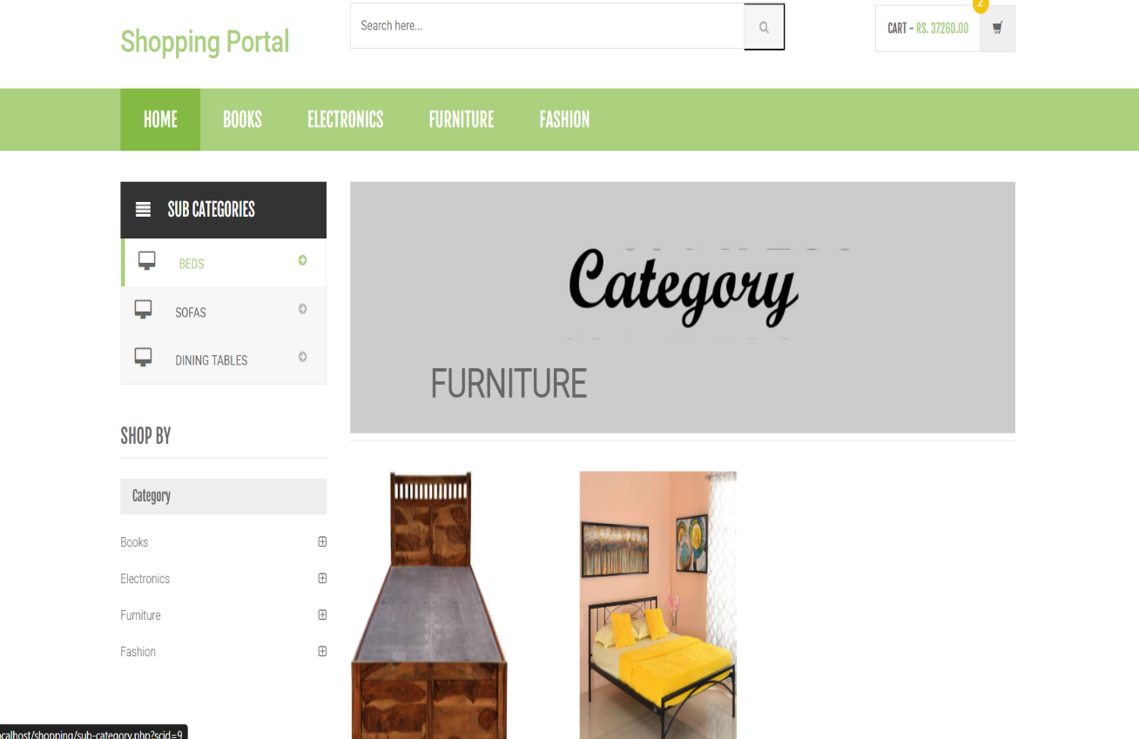

Fashion:

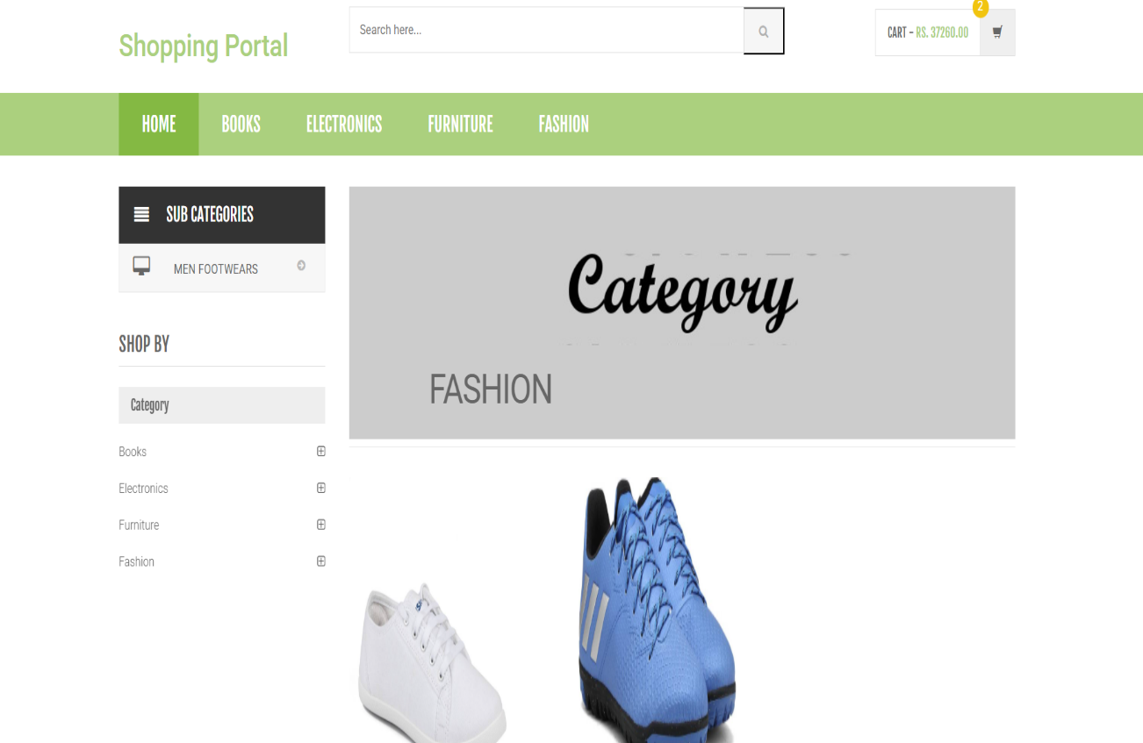

Admin:

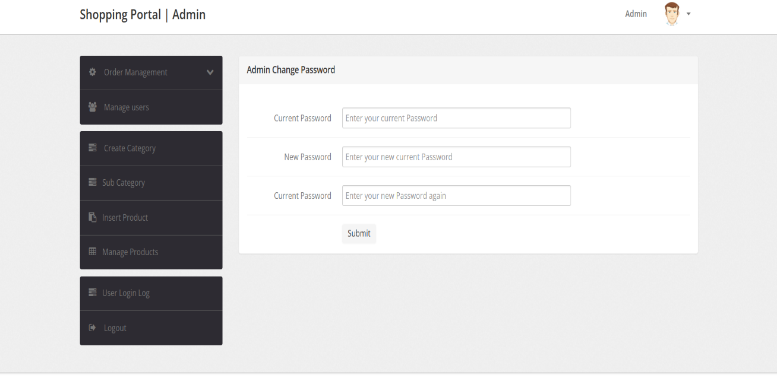

Oreder history:
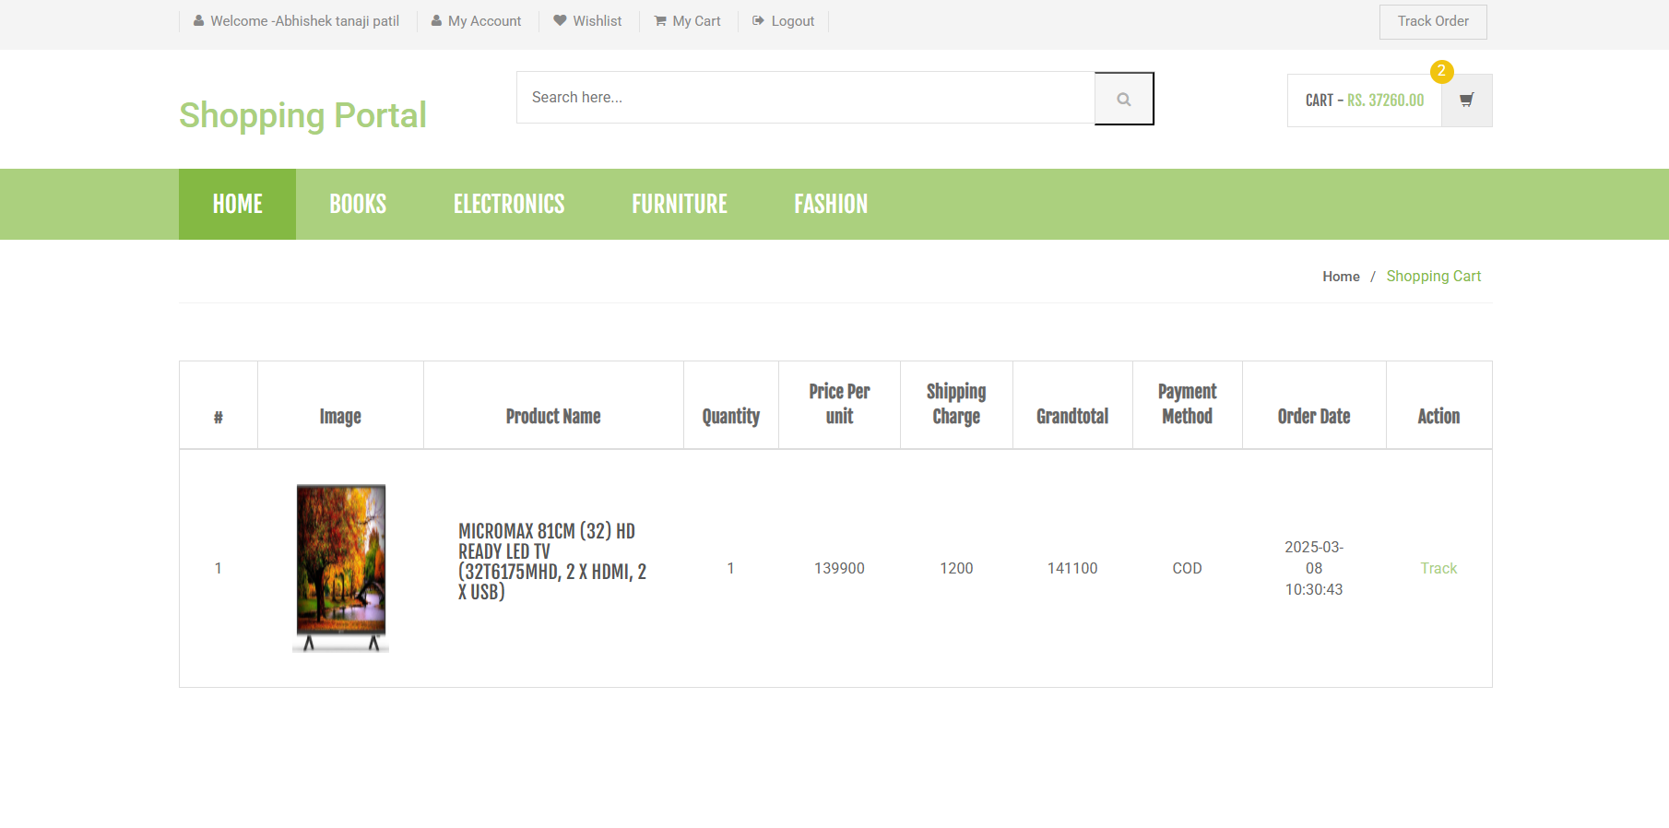

Cart:

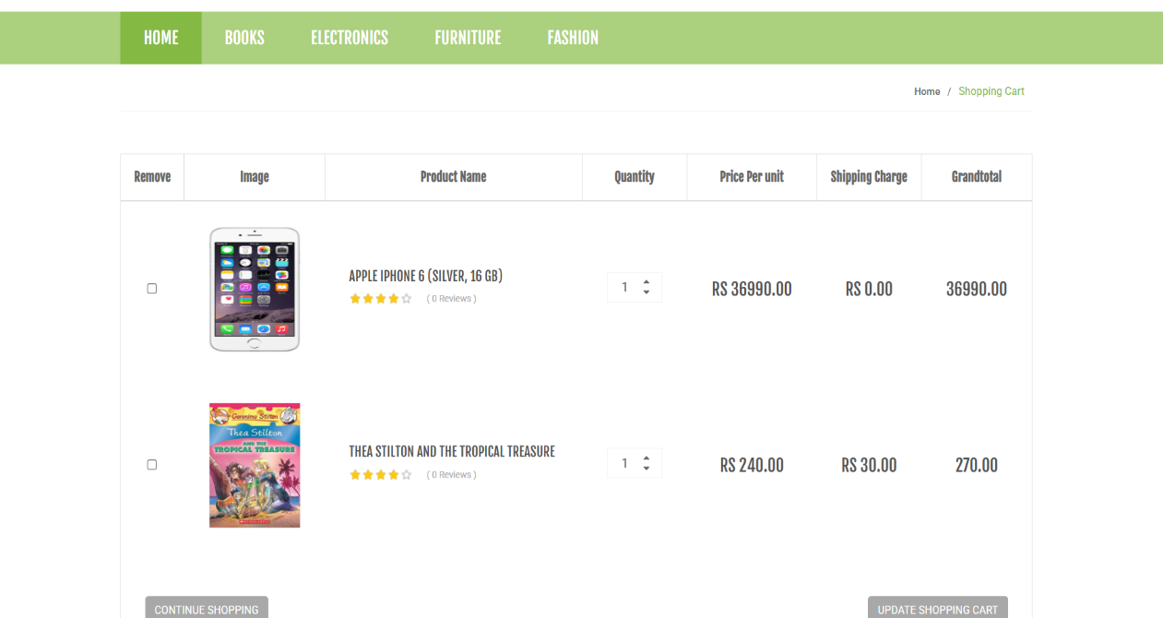

Implementation

- System Requirement:

- We use PHP for frontend development and we include five tabs which is Home, Books, Electronic, Furniture, Fashion. This all include into the frontend.

- We use is JavaScript for backend and data will be store into Xampp. The data will store into various categories such as cart, login, admin etc.

- Hardware:
  - Processor: Intel Core i5 or higher with at least 4 cores.

  - RAM: At least 4GB to 6GB of RAM for efficient performance and handling multiple users.

  - Storage: A 256GB or higher SSD or HDD storage.

  - Network interface: A reliable Megabit Ethernet interface to ensure fast connectivity and high-speed data transfer.

  - Power supply: A high-quality power supply unit with a backup power supply to ensure uninterrupted power supply and prevent data loss.

- Software:
  - Text Editor: Visual Studio

  - Web Browser: Google Chrome, Mozilla Firefox, etc

Output (Report)

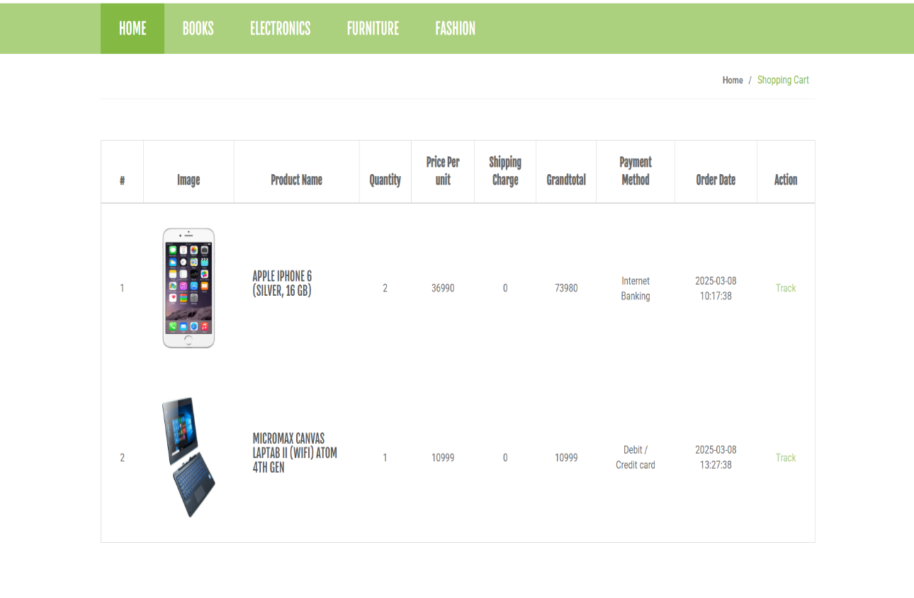

CONCLUSION AND SUGGETION

Limitations:

- Technological Constraints:
  - Limited access to high-speed internet and older devices may impact user experience.
  - Compatibility issues with certain browsers may restrict accessibility.

- Geographic Limitations:
  - Delivery services may be regionally constrained.
  - Adapting to diverse regional preferences poses challenges.

- Security Concerns:
  - Potential data breaches and unauthorized access are ongoing concerns.
  - Ensuring secure transactions and user privacy requires constant attention.

Conclusion:

- User-Centric Approach:
  - Prioritize user feedback for continuous improvement.
  - Regular updates based on user suggestions ensure competitiveness.

- Adaptability and Innovation:
  - Addressing limitations is crucial for long-term success.
  - Commit to technological advancements for sustained innovation.

- Collaboration and Feedback:
  - Foster collaboration with users, stakeholders, and the development team.
  - A transparent feedback loop is vital for refining features and addressing limitations.

Suggestions:
- Enhanced Customer Support:
  - Implement robust customer support for prompt issue resolution.
  - Provide clear channels for user feedback to enhance engagement.

- Expand Delivery Services:
  - Explore partnerships for broader geographic coverage.
  - Optimize logistics for faster and more reliable deliveries.

- Invest in Cybersecurity:
  - Allocate resources for continuous cybersecurity measures.
  - Educate users on security best practices to build trust.

References

Websites:

1) MDN docs: https://developer.mozilla.org/en-US/
2) JavaScript docs: https://developer.mozilla.org/en-US//docs/web/javascript
3) YouTube
Books:
- Learn creative
- Eloquent JavaScript.

